**Enterprise Resource Planning**

*Of*

**ZAB**

**Training User Manual**

**(SV–12.3.0 | MV–1.0.0)**

**For**

**ASIATIC GROUP**

**Accounts Receivable**

**Index**

|  |  |  |
| --- | --- | --- |
| **Option No.** | **Option Name** | **Page No.** |
|  | Transfer To A/R | **03** |
|  | Money Receipts | **09** |
|  | Transactions | **13** |
|  | Reports | **14** |

# Transfer To A/R

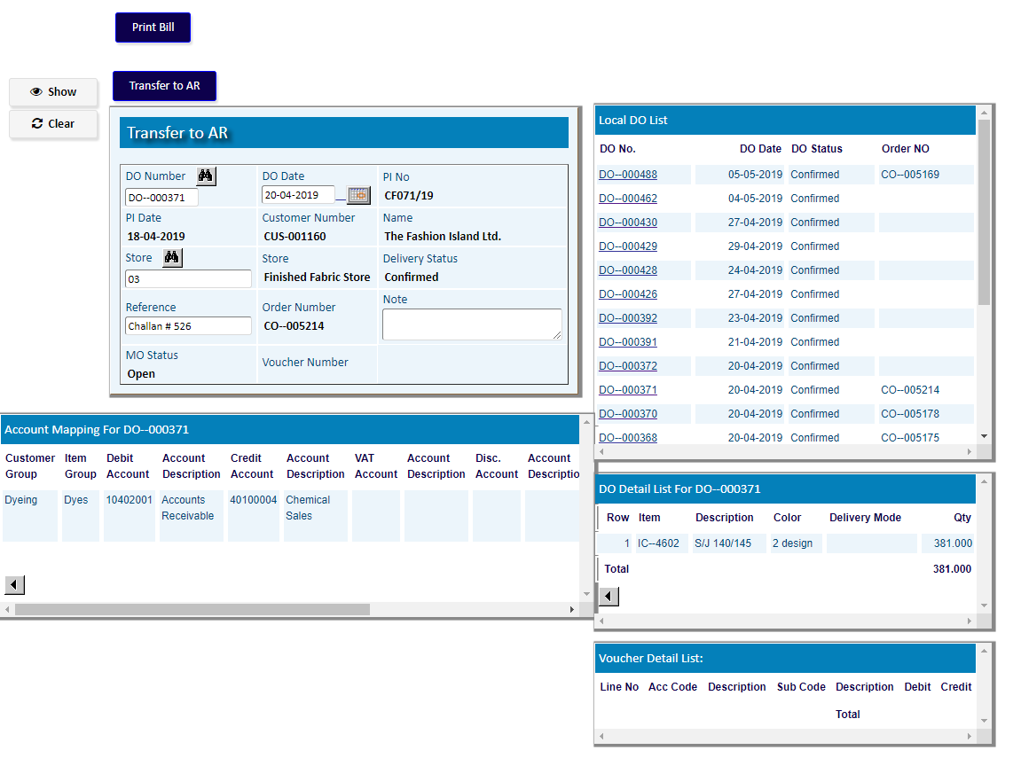**Transfer TO A/R (For Local DO)**

|  |  |
| --- | --- |
| **Step 1** | Main Menu (Home Icon) **> Financial Accounts>**  **Accounts Receivable >** Transfer TO A/R (Others) |
| **Step 2** | Select a **DO** number from the Local DO list |
| **Step 3** | Click **Transfer To A/R** |

**Result** : Do will be transfered to AR & a voucher will be created.

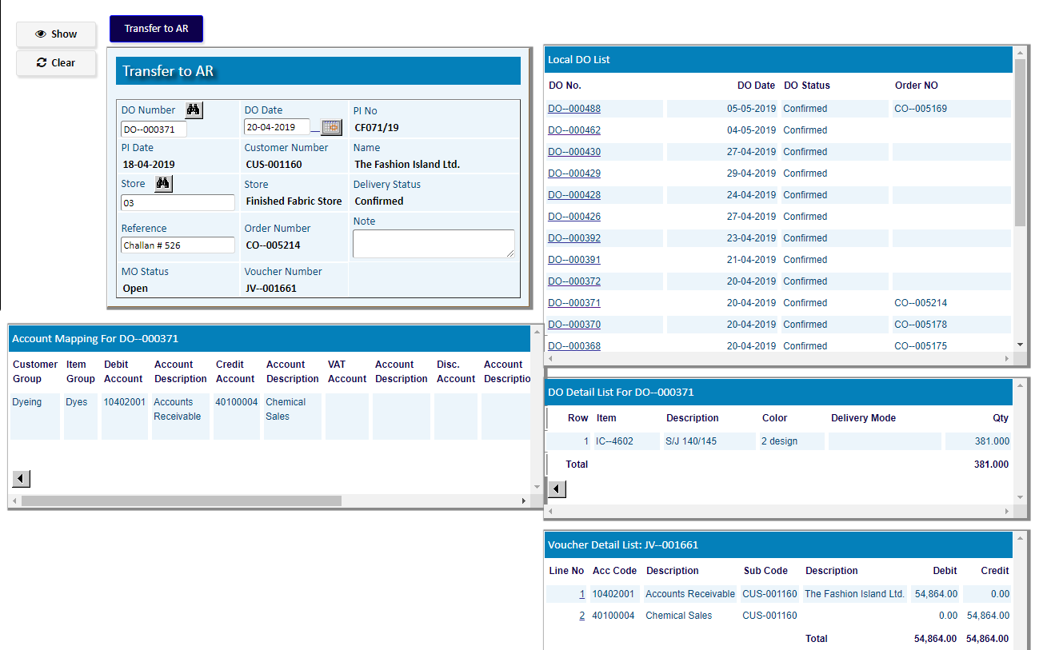

A voucher of the DO has been generated.

**Transfer TO A/R (for a DO with CI)**

|  |  |
| --- | --- |
| **Step 1** | Main Menu (Home Icon) **> Financial Accounts>**  **Accounts Receivable >** Transfer TO A/R (CI) |
| **Step 2** | Select an **Invoice Number (CI)** & then click **Show** |
| **Step 4** | If CI No. not linked with DO, then Click on **DO** **Update** button. |

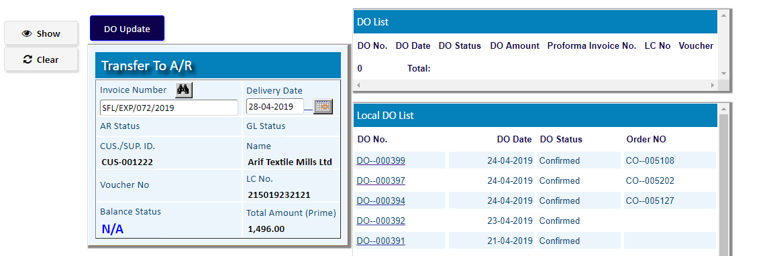

1. Choose a DO Number
2. Select an Order Number for the DO
3. Click **Save**
4. Click on **Return** button.

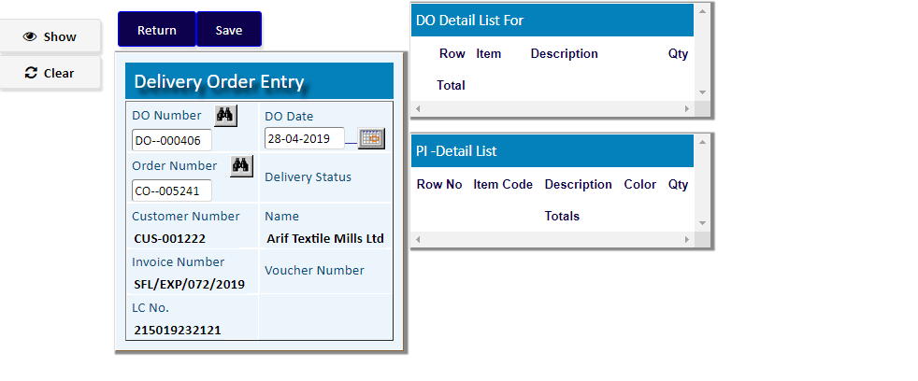

After Clicking on **Return** button of **Delivery Order Entry** screen,

Click on **Transfer To A/R** button to generate a voucher of the DO

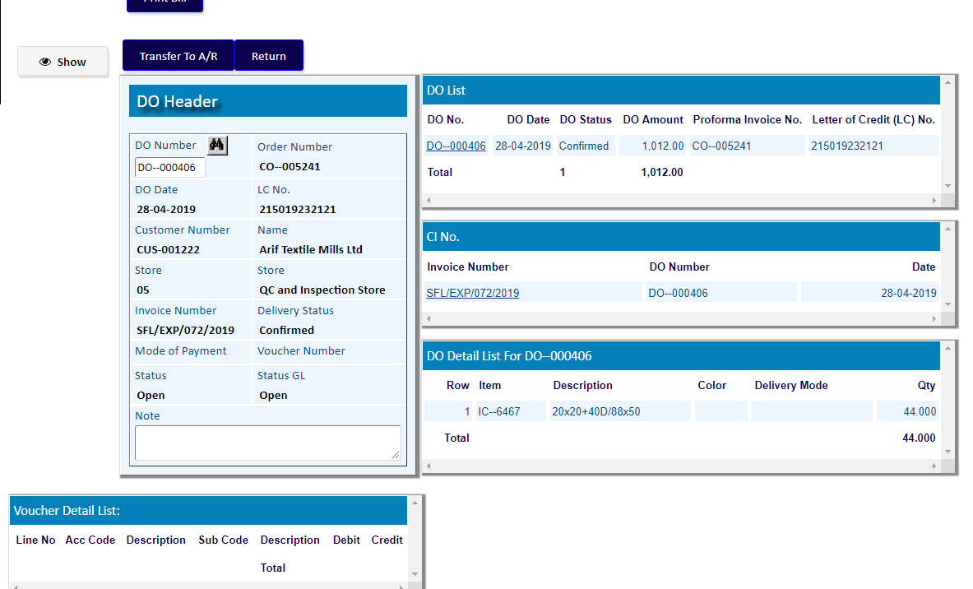

A voucher of the DO has been generated.

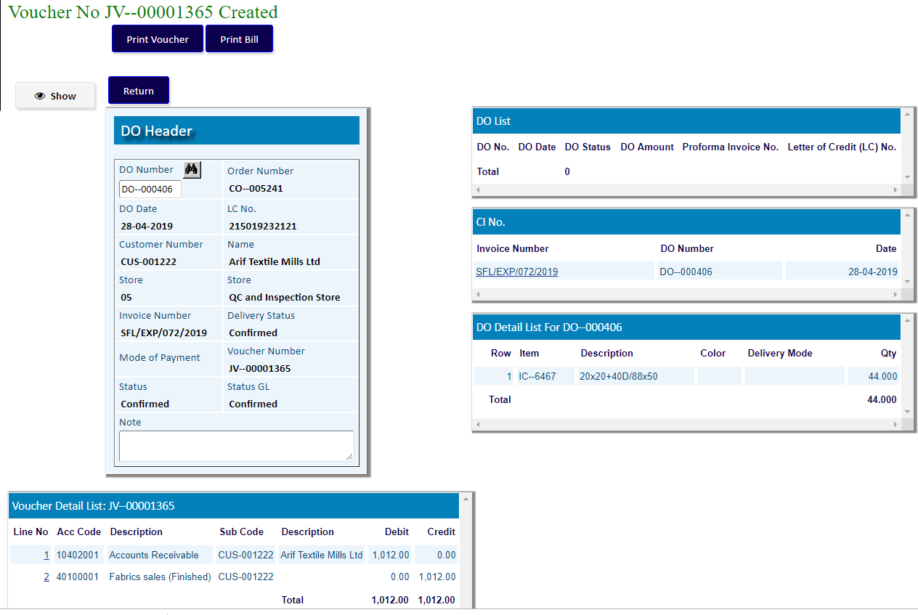

# [Money Receipts](http://192.168.1.17:8080/zab/login?screen=arcas&option=Money+Receipts+and+Allocation&menuname=ar)

|  |  |
| --- | --- |
| **Step 1** | Open System **>** General Accounts **>** Accounts Receivable > Money Receipts |
| **Step 2** | Choose Customer Code, Account No. & Payment Type |
| **Step 3** | Write Total Received Amount & then Click **Add** |
| **Result** | New Money Receipts will be Created |

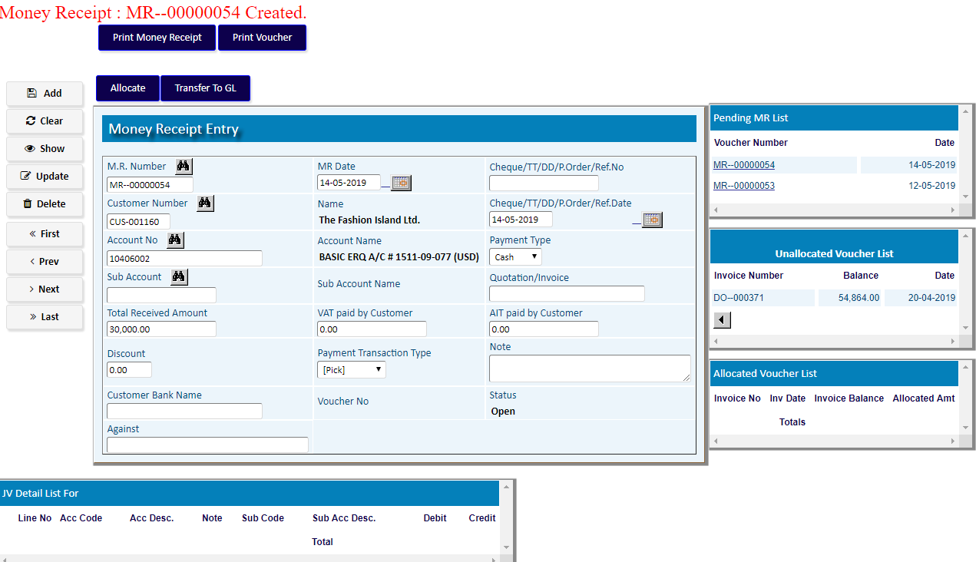

Click **Allocate** button to allocate MR amount from DO/Invoice amount

1. Choose an Invoice Number from the Unallocated Voucher List
2. Click **Add**
3. Click **Return** after Allocation

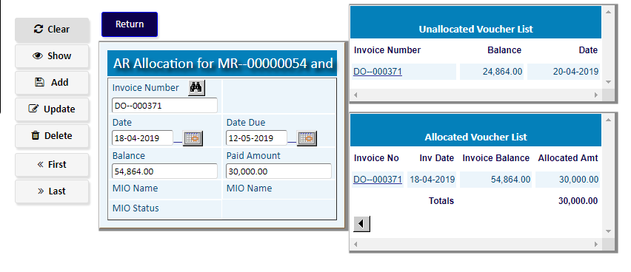

After Return to MR, Click **Transfer To GL**

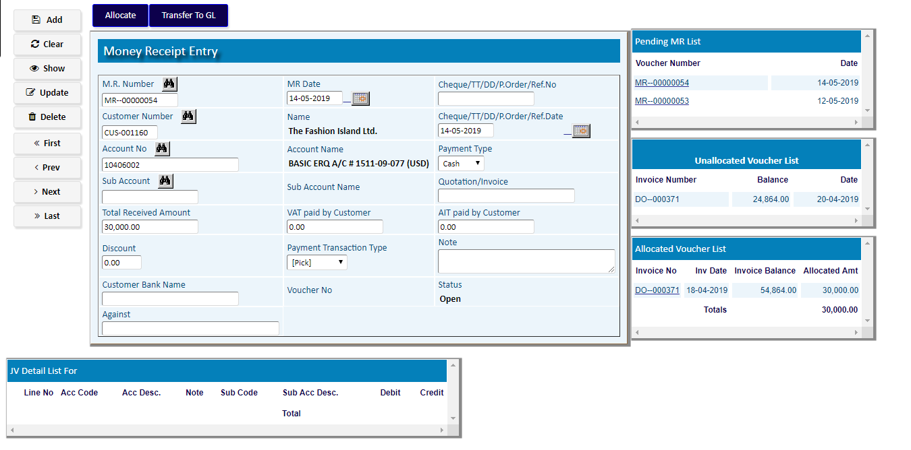

**Result:** A new voucher for the MR will be generated.

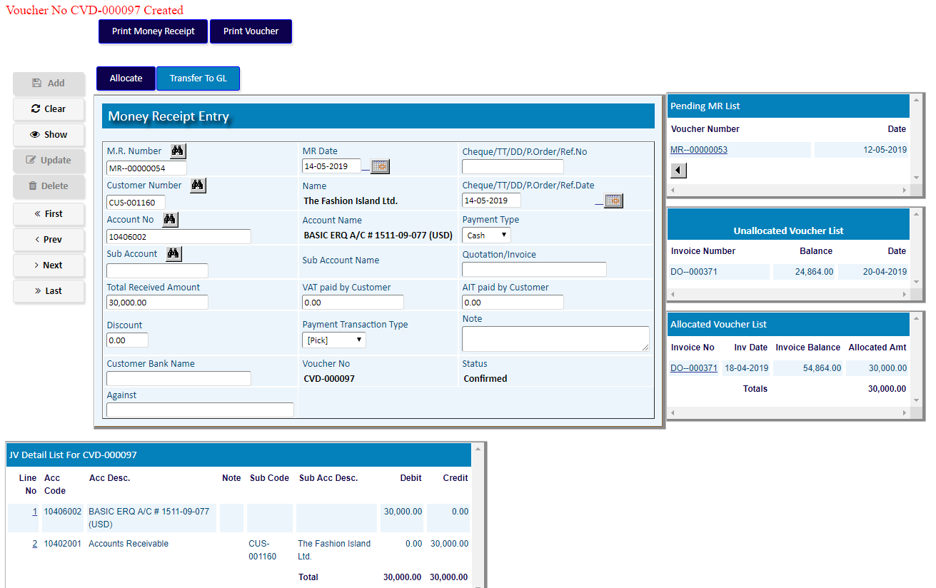

# Transactions

|  |  |
| --- | --- |
| **Step 1** | Main Menu (Home Icon) **> Financial Accounts>**  **Accounts Receivable >** Transactions |
| **Step 2** | Select a **DO** number as Transaction No |
| **Step 3** | Click **Show** |

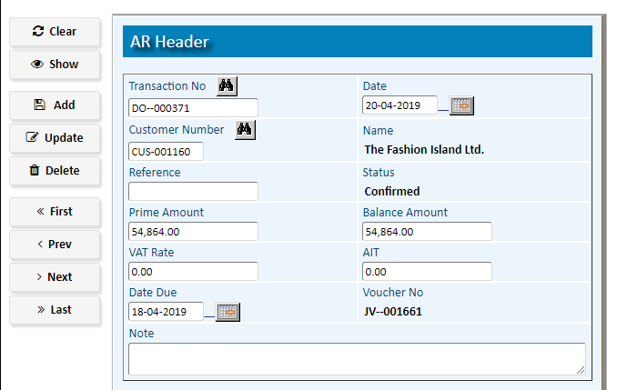

# Reports

## Printing report to preview data

|  |  |  |  |
| --- | --- | --- | --- |
| **Step 1** |  |  | Open System **>** Financial Accounts > Accounts Receivable **>** Reports |
| **Step 2** |  |  | Select a report option. |
| **Step 3** |  |  | Select the parameters (From date, To date & other fields) to specify data previewing in the report. |
| **Step 4** |  |  | Click **“View Report”** to preview in print format. |
| **Result** |  |  | The report is previewed in print format. |

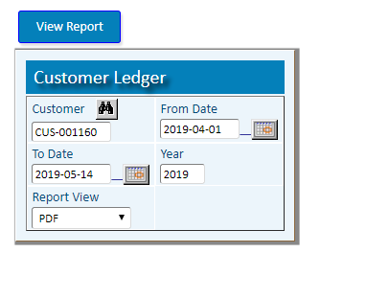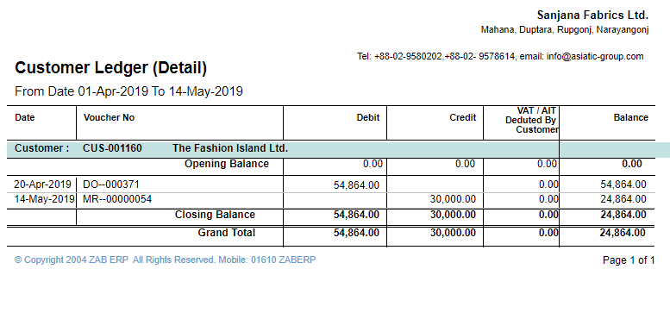

Report Output